Profile: Normal good - typical

File: ad001_200_ERDS in dataFiles

Profile associated in indivAnalysisERDS_simpl: Full stereo

Figure:

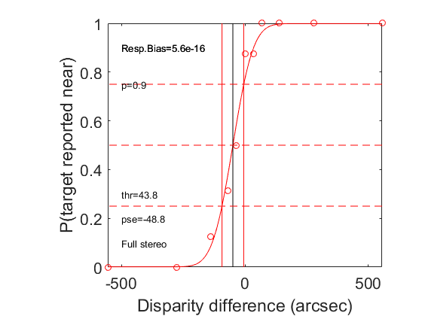

Profile: Normal good with small Panum

File: ad007_200_ERDS in dataFiles

Profile associated in indivAnalysisERDS_simpl: Full stereo / small Panum

Figure:

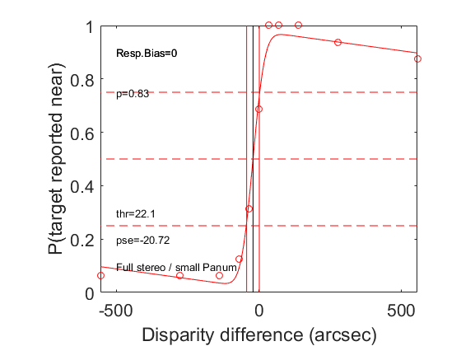

Profile: stereoblind typical

File: am1_2000 in dataFiles2

Profile associated in indivAnalysisERDS_simpl: Stereoblind

Figure:

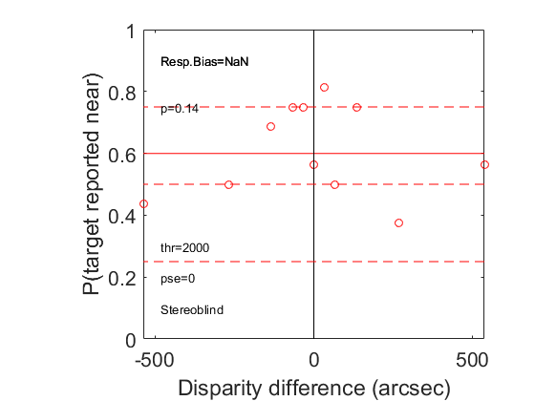

Profile: stereoblind with some kind of partial response inversion

File: hb01_2000 in dataFiles2

Profile associated in indivAnalysisERDS_simpl: Stereoblind

Figure:

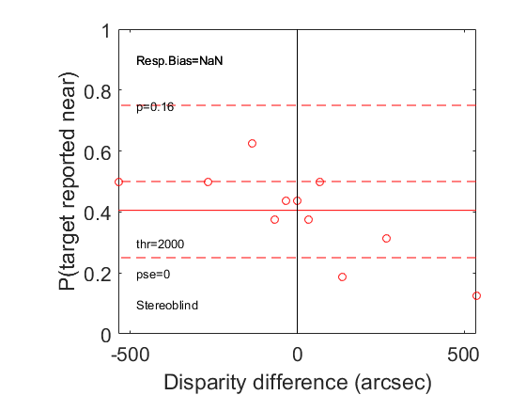

Profile: typical uncrossed (divergent) blind

File: hb85_post_2000 in dataFiles2

Profile associated in indivAnalysisERDS_simpl: Uncrossed-blind

Figure:

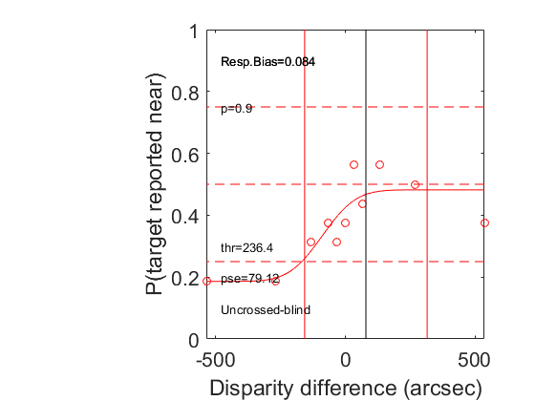

Profile: poor crossed (convergent) blind

File: KR104_post2_2000 in dataFiles2

Profile associated in indivAnalysisERDS_simpl: Crossed-blind

Figure:

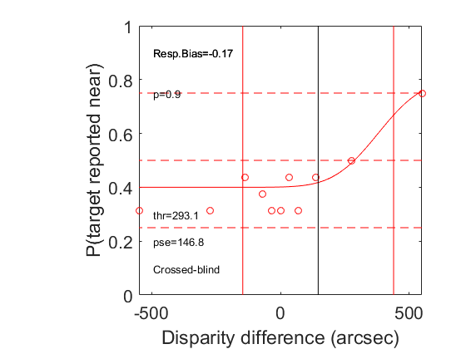

Profile: Good crossed (convergent) blind with small Panum

File: ken001_2000_014_200_ERDS in dataFiles

Profile associated in indivAnalysisERDS_simpl: Crossed-blind / large fixation disp.

Figure:

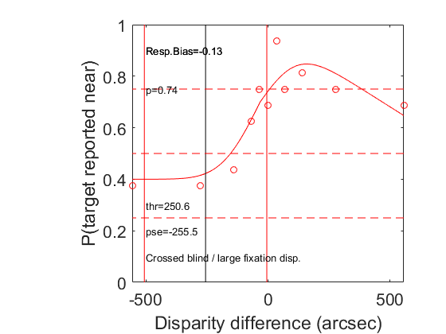

Profile: Good full-range stereo with large fixation disparity (far fixation)

File: L_001_2_200_ERDS in dataFiles

Profile associated in indivAnalysisERDS_simpl: Full stereo / large fixation disp. (far)

Figure:

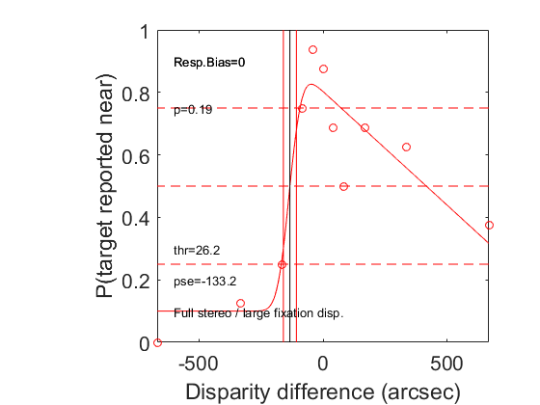

Profile: Good full-range stereo with large fixation disparity (near fixation)

File: 005_T3_14 in dataFiles3

Profile associated in indivAnalysisERDS_simpl: Full stereo / large fixation disp. (near)

Figure:

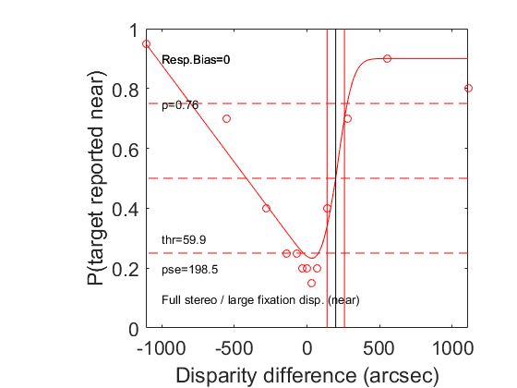

Profile: Good stereo but uncrossed-blindness and large fixation disparity (near fixation)

File: jul01_200_ERDS in dataFiles

Profile associated in indivAnalysisERDS_simpl: Uncrossed blind / large fixation disp. (near)

Figure:

